**TRAVEL BUDDY**

**A Platform That Connects Travellers with Local Guides**

**A MINI PROJECT REPORT FOR THE COURSE**

**CB19501 DESIGN THINKING**

***Submitted by***

**VARADHARAJAN S**

**(221401112)**

**SANDEEP VISHWA R**

**(221401081)**

**TATIREDDY DINESH KUMAR**

**(221401102)**

**III YEAR B. Tech**

**COMPUTER SCIENCE AND BUSINESS SYSTEMS**



**Department of Computer Science and Business Systems**

**Rajalakshmi Engineering College**

**Thandalam, Chennai-602105**

**November 2024**

**BONAFIDE CERTIFICATE**

Certified that this Thesis titled “**TRAVEL BUDDY**” :-A Platform That Connects Travellers with Local Guides”is the bonafide work of **VARADHARAJAN S** **(221401112)**, **SANDEEP VISHWA R (221401081)** and **TATIREDDY DINESH KUMAR (221401102)** who carried out the work under my supervision. Certified further that to the best of my knowledge the work reported here in does not form part of any other thesis or dissertation on the basis of which a degree or award was conferred on an earlier occasion on this or any other candidate.

**Student Signature with Name**

1.

2.

3.

Signature of the Supervisor with date

Dr. V. Murali Bhaskaran

Signature Examiner-1 Signature Examiner-2

**TABLE OF CONTENT**

**CHAPTER NO. TITLE PAGE NO.**

**ABSTRACT 4**

**LIST OF TABLES 5**

**LIST OF FIGURES 5**

**LIST OF SYMBOLS, ABBREVATION 6**

1. Introduction
   1. Design Thinking Approach 7
   2. Stanford design thinking module 10
2. Literature Review 12
3. Domain area 14
4. Empathies stage 16
5. Define stage 17
6. Ideation stage 19
7. Prototype stage 22
8. Test and feedback 27
9. Re-design and implementation 30
10. Conclusion 32
11. Future work 32
12. Learning outcomes 32

Reference 34

* Journal paper
* Website

**ABSTRACT**

Visiting new destinations always a brings in thrill and curiosity, Tourists often face challenges when exploring new places due to a lack of local knowledge and unfamiliarity with the area. This can lead to missed opportunities, inefficient travel plans, and a less enriching experience. Furthermore, finding trustworthy and knowledgeable local guides can be difficult, and tourists may struggle with transportation logistics, especially in unfamiliar regions.

To solve these “Travel Buddy” is a platform that would help the travellers to connect with local guides who are called as ‘buddies’ in our app and well-aware about their place so that the traveller could make most out of their trip.

Firstly, Travel Buddy is all about connecting travellers with local guides. When a traveller is looking for something specific, such as hidden secrets about the city, language help or cultural advice, buddies are at their disposal to give that helping hand, making travels an overall easier and more enriching experience. This allows travellers to experience new destinations with more confidence and comfortness.

It also gives the local guides who work with it, a platform to share their expertise and love of their place. It is giving them a way to make money as they market their community and culture. This end-to-end interchange helps in connecting locals with travellers, benefiting both individuals in turn and as they progress through each other.

It lets you create relationships that last without borders a spot to meet people from anywhere in the world. Made buy travellers for travellers, the platform encloses the gap between those who travel and the destinations they encounter, ensuring each journey is a story worth telling with fulfilled satisfaction.

**LIST OFTABLES**

|  |  |  |
| --- | --- | --- |
| **TABLE.NO** | **TABLE NAME** | **PAGE NO** |
| 1. | Overview of Design Thinking Stages for Travel Buddy | 15 |
| 2. | Value proposition statement for Travel Buddy | 20 |
| 3. | Features and Functionalities of Travel Buddy | 21 |
| 4. | Working of Travel Buddy | 25 |

**LIST OF FIGURES**

|  |  |  |
| --- | --- | --- |
| **FIG.NO** | **TABLE NAME** | **PAGE NO** |
| 1. | Stanford Design Thinking Model | 11 |
| 2. | Mind map | 19 |
| 3. | Prototype for Travellers | 22 |
| 4. | Prototype for Buddy | 23 |

**SYMBOLS &ABBREVATION**

1. OTAs - Online Travel Agencies
2. MFA - Multi-Factor Authentication
3. QA - Quality Assurance
4. B2B - Business-to-Business
5. C2C - Consumer to Consumer
6. B2C - Business to Consumer
7. SVG - Scalable Vector Graphics
8. BUDDY - Local Guides

**1.INTRODUCTION**

Travel Buddy is a service which links tourists to local guides and provides them personal assistance as well as their views that make wandering new lands convenient and rewarding. If you are travelling abroad or a new place, to get some reliable and local advice can help. Enter Travel Buddy, a platform that connects travellers with local guides—referred to as buddies—who knows the region well and can offer customized recommendation and assistance on the ground.

The platform makes travellers’ trips more enjoyable and gives locals to offer a piece of their culture, knowledge or skills by creating a source of revenue. Travel Buddy makes these connections meaningful in order to have a real travel experience that travellers could enjoy by having a help from buddies sharing the soul of city.

**1.1.DESIGN THINKING APPROACH**

**1.1.1. Stanford Design Thinking Model**

The Stanford design thinking model is developed at Stanford's d.school[3]. It serves as the foundation for modern design thinking; that involves deep engagement with a customer and iteration of solutions based on feedback.

**Stages**

**Emphasize:** This is step one, in which the designers engage in deep user research by observing and engaging with the users' world, in order to understand their pain points and needs.

**Define:** Information collated during the Empathy phase is synthesized to present a clear problem statement, often called a "Point of View" (POV).

**Ideate:** A designer creates or identifies a set of possible solutions to that problem. Creativity takes centre-stage and judgement is thrown out so as not to limit ideas.

**Prototype:** Copies of solutions are made rapidly and inexpensively, where they can be used to determine if they solve the user's problem.

**Test:** The prototypes are tested with real users in order to allow feedback to become an iterative cycle of creation. This is when the developing cycle will often complete a loop back through ideation or prototyping.

**1.1.2. The Double Diamond model**

It was developed by the UK Design Council and is widely used within design fields. It splits the design process into two diamonds: Discover/Define and Develop/Deliver.

**Phases**

**Discover:** This is the divergent thinking phase where designers mainly focus on understanding the problem broadly, exploring it from all sides, and gathering insights from various sources. This is where research and empathy appear to play a very central role.

**Define:** After diversing it converges to a core problem definition based on all the insights acquired through exploration.

**Develop:** Generating multiple ideas and solutions for the problem converges during this second phase of convergence. Prototyping and testing are two very important processes within this stage.

**Deliver:** Lastly, ideas converge into one well-defined solution, which then is applied and tested for effectiveness.

**1.1.3. IDEO Design Thinking Model**

IDEO is a pioneer in design thinking and uses a human-centered, iterative approach. They emphasize understanding the real needs of users; hence their model is often used for small-scale and large-scale projects as well.

**Phases:**

**Inspiration:** This is very much like the "Empathize" stage, whereby observation with users is also done and understanding of latent needs and insights is progressed.

**Ideation:** This is the ideation stage where through brainstorming a plethora of ideas, creativity is encouraged with no judgments to be carried out.

**Implementation:** It's exactly like the iterative process used by Stanford. Prototypes are built and re-crafted based on feedback from users, but again, this is integrated in the final stage of implementation. Testing and iteratively improving solutions are an important part of the final implementation stage.

**1.1.4. IBM Design Thinking Model**

IBM also came up with its own scalable design thinking framework for big business. Its bottom line has been speed, collaboration, and iteration with a continuous circle of feedback.

**Stages:**

**Understand:** Just as in "Empathize" in other models, this involved understanding the problem greatly from the user's perspective through research and gathering data.

**Investigate:** The team generates many ideas and possible solutions through brainstorming. They then quickly prototype the solutions to see if the assumptions contained within them are tenable.

**Prototype:** Prototypes are designed and executed to test functionality in real-world environments.

**Evaluate:** Feedback is garnered from users to refine the prototype, and this continues in a loop of iteration.

**1.1.5. IIT Bombay Design Thinking Model**

The IIT Bombay model is a system applied in academic and industrial projects and for Indian societal and cultural requirements. This model is modeled according to the peculiar challenges and resources of India.

**Phases:**

**Emotional Intelligence:** Emphasize understanding the user with a focus on local context and cultural nuances.

**Statement of Definition:** Narrow the broader insights into specific, localized problem statements that are applicable only to the region.

**Idea Generation:** Generate ideas that meet the specific requirements of local needs, especially in resource-constrained environments.

**Prototyping:** Build low-cost scalable prototypes that apply to the Indian markets.

**Testing:** Test prototypes in reality with local communities to accumulate feedback and iterate.

**1.2. STANFORD DESIGN THINKING MODULE**

The Stanford Design Thinking Model is a systematic approach that helps to develop user focused solutions in iterative manner.

**1.2.1. Empathize:**

It starts with knowing the voice and buyer persona. This means that Travel Buddy listens to potential travellers and guides to understand the problems they face (e.g. managing their travel plans, attractions or UI pain points). User Research: Phase1 User research begins with interviews, surveys, user observation to get a more detailed on the experiences and behaviours they unfold there was a time or ends.

**1.2.2. Define:**

User problems and needs from discovery of insights gathered. Creating a problem statement that sums up the synthesis of information “Travellers need an easy-to-use system for tracking details of their travel while they need to be able to communicate with guides in a predictable way, all keeping our data secure”.

**1.2.3. Ideate:**

Using the problem above, our team brainstorm the ideas. For Travel Buddy that may consist of brainstorming feature-ideas like secure login methods, clean forms for international users or real-time alerts while travelling. Rather, the idea is to look at a variety of solutions that can be applied.

**1.2.4. Prototype:**

Travel Buddy will have the prototype with its suggested solutions. These can be anything from simple wireframes of the user interface to mock-ups of the registration process, and even stubs for data entry. Prototyping gives the team a medium to rapidly visualize and test ideas, providing an opportunity to refine designs quickly.

**1.2.5. Testing**

The last stage is to give the prototypes to real users and ask for their feedback. Specifically, Travel Buddy has completed usability testing with travellers and guides on multi-factor authentication and country code selection for the phone while running pilots to deal with all UX related issues. It captures feedback, which can be used to identify where improvements are needed and ensure that the platform meets user requirements efficiently.

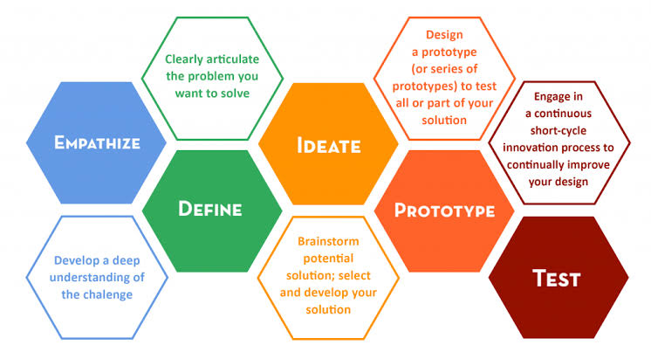

**Figure:1 – Standford Design Thinking**

**Source -** [**https://bit.ly/3tuAYnW**](https://bit.ly/3tuAYnW)

**2.LITERATURE REVIEW**

**2.1. Travel and Tourism in the Digital Age [1]**

The rapid pace of development in digital technology has greatly impacted the travel and tourism industry. Plans, bookings, and even the experience of traveling have undergone such strong evolution. And as many studies show, it is indeed true that digital platforms are central to connecting the traveller with guides, accommodations, and experiences (Buhalis, 2019) [5]. More in the direction of custom and flexible options, the traditional travel industry has evolved, with OTAs, mobile apps, and peer-to-peer platforms like Airbnb moving it along. With increasing popularity, travellers are attaching to various platforms that provide contact with local guides or fellow travellers in pursuit of unique experiences, which can be tailored to specific needs and appeal beyond typical tourism packages (Fitzpatrick, 2019) [6]. Regarding this shift, the Travel Buddy project therefore takes up offering a platform that connects similarly-minded travellers and guides to curate specific experiences.

**2.2. Peer-to-Peer Platforms: Definition and Growth**

A host of traditional industries has been revolutionized due to the advent of the sharing economy in travel. Peer-to-peer platforms are an interface that enables users to connect peer-to-peer, bypassing the middleman. Traveling, therefore, becomes an experience which seeks the more localized, authentic experience that online travel platforms like Couchsurfing [9], Meetup [10], or even ToursByLocals [11] have created in niches. Further research delves into the fact that aspirations constantly change in the minds of travellers, as they go on to search for authenticity in their immergence with a broad stretch of cultures and communities involved (Richards, 2018).

**2.3. Tourism Companion Services [2]**

The element of the travel companion has been present in several works but, in most cases, it centres on one backpacker seeking companionship during their travels (Paris, 2017)[7]. Social interaction and safety are among the prime movers for travellers who are in pursuit of traveling with companions. Studies also highlight the fact that trust builds up in such platforms as connection with strangers for travel can be concerned with safety and reliability. Thus, Travel Buddy adds verification systems and reviews with the intention of building a trusting relationship between travellers and guides, thereby ensuring a safe and enjoyable experience for all users.

**2.4. Design Thinking in Travel Platforms**

Travel platforms have shown the application of the design thinking practice as an emphasis on experience, empathy, and development in iterations. In the case of Travel Buddy, the design thinking approach allows for designing and applications of principles such as empathy on user needs and pain points that a traveller is experiencing in real time. As a matter of fact, research favours the notion that platforms which pay more attention to understanding user behaviour and needs tend to increase satisfaction rates as well as involvement among users (Liedtka, 2018) [2].

**2.5. Domain Papers**

Tourism domains keep changing. Such change is because of the development of new technologies with the aim of seeking improved user experience. For example, TourVista is a full-web application that aims at making travel planning easier and enhanced [1]. The web application enables Customizable Travel Packages through which customers can have their options customized according to their preferences. It also avails access to Expert Tour Guides. Through the guides, it connects the traveller to the experienced and vetted guides. In addition to that, the system allows for Seamless Hotel Booking, which makes it easier for tourists to make a booking within the system. Its other impressive features comprise Real-Time Weather Forecasting, which gives continuous up-to-date weather information at places they intend to visit and adjust their travel plan accordingly.

**2.6. Design Thinking Papers**

Design Thinking (DT) is increasingly surfacing its role in the resolution of complex, so-called "wicked" problems across sectors including tourism. It is characterized as an iterative, human-centred approach to dealing with problems. The Stanford Design Thinking model has five stages: Empathize, Define, Ideate, Prototype, and Test. This process lets teams develop innovative solutions by focusing on user needs and continually refining ideas based upon real-world feedback. In both TourVista and The Virtual Tourist Guide, DT application ensures that these sites meet the technical requirements in a strict sense but offer fluid, personal experience for the users. For example, in the Empathize stage, the company can be collecting insights from travellers on what ails them in their travel. Definition may be zeroing down to the exact problem: probably lack of local information or maybe an inefficient system for booking.

Prototype and Test stages of DT are very highly applicable for tourism platforms. Creating an early version of the web application and testing it with real users lets developers obtain very important feedback, which would make user interfaces more user-friendly and the overall functionality of the product better. This iterative process is bound to ensure that the final product is user-friendly, highly functional, and appropriate for a variety of different kinds of users.

**3.DOMAIN AREA - TRAVEL & TOURISM**

Travel and tourism are an ever-responding dynamic industry continually responding to forces of technological changes and consumer expectations. In this regard, there has been a proliferation of more services, such as Travel Buddy, developed to meet these same aspirations of the increasing demands of travellers seeking hassle-free, personal, and immersed experiences during travels. Personalization, immediacy of data, and fluid interfaces in interacting with the service come into play, thus leading to designing services that meet those needs.

Travel Buddy plans to meet with this trend by providing travel solutions that are individualized. This kind of personalization is derived by using the profiles and preferences of the users, thus enabling the platform to provide destination choices and activities as well as types of accommodations for past behaviours and preferred choices of the users. Integration of live data will enable Travel Buddy to ensure travellers acquire up-to-date information relevant to their destination regarding weather updates, transportation timetables, and other local events. This helps in better decision-making for travellers and changes plans based on the situation when being on the trip. As such, this provides a sense of increased convenience while decreasing stress related to planning a trip.

Travel Buddy offers the strongest user authentication as all data and transactions are included, therefore providing maximum security. In today's cyber world, security is a big issue, and especially in terms of holidays or travel plans where not only personal information but payment details are also in the picture. This is extremely important as, in the digital world, loads of issues concerning hacking as well as other cybersecurity issues are present.

The travel and tourism landscape are going through a new trend with digital and mobile-first solutions becoming the latest trends. Today, the traveller wishes to have all aspects of the journey treated from a single interface, ranging from booking flights and accommodations to arranging local guides and experiences. Travel Buddy meets the said need as it integrates numerous services into one platform that allows tourists to book their tours, hire a local guide, and even find what would interest them locally.

**Table 1. Overview of Design Thinking Stages for Travel Buddy**

| **Stage** | **Description** | **Key Activities in Travel Buddy** |
| --- | --- | --- |
| Empathize | Understand the users (travellers and guides), their needs, and the challenges they face in the travel ecosystem. | Pain points are best gauged by conducting interviews with potential users, surveys, and field research on issues such as guides' trustworthiness, safety, and ease of planning. |
| Define | Synthesize the information gathered to clearly define the core problems travellers face. | Create problem statements like "How might we ensure safe and verified guide services for single travellers?" |
| Ideate | Brainstorm potential solutions to the defined problems, focusing on user needs and innovative approaches. | Generate ideas that could include a real-time review system, verified local guides, or even tailored trip recommendations using past user feedback. |
| Prototype | Develop a simplified version of the platform to test core features with actual users. | Design low-fidelity mock-ups or wireframes about the most essential features of the platform: guide verification and matching traveller to guide. |
| Test | Test the prototypes with real users and gather feedback on the functionality and user experience. | Pilot the platform among a few users; gather usability, effectiveness, and overall satisfaction with guide-traveller matching and trip planning from such feedback. |
| Re-Design | Based on the feedback from testing, iterate and improve the platform's design and features to better meet user needs. | Based on the feedback, redesign features to include registration, guide verification, and user interface to make it more user-friendly and address concerns about security or efficiency in the application. |
| Implementation | Launch the platform after final modifications, ensuring all key features work seamlessly and meet user expectations. | Deploy the Travel Buddy platform with all essential features, ensuring that all user feedback has been addressed and that the platform is ready for broader use. |
| Learning Outcomes | Reflect on the insights gained from the project, including challenges faced and lessons learned about the travel industry and platform development. | Three key takeaways that sum it all: value of user feedback, security in travel services, the impact of trust in the platform, and some technical learnings on scale. |

**4.EMPATHIZE STAGE**

In the Stanford Design Thinking model, the Empathize stage is used to make sure that we design solutions from a place of deep empathy with the end users. In case of Travel Buddy, this stage would be to meet different travellers and guides, understand their experiences and what they want & rectifying their pain points.

**4.1. Activities to be performed in Travel Buddy**

**Gaining a traveling perspective**

All types of travellers, face lot of complexities while managing travel plans. In the empathize phase, we did extensive user research to better understand what they go through every day. Through our research we determined common issues travellers face included.

**4.1.1. Interacting with the Guides Community**

The other primary user group, the guides, have their own complicated issues to work through. Travel Buddy interviewed various tour guides in different regions, interviewing them and holding focus groups in the empathize stage.

Many local guides said that they had trouble finding tourist to connect with them. Most of the time they connect with travellers on word-of-mouth with travellers.

**4.1.2. Communication Issues:**

Just like travellers, guides occasionally have communication issues, particularly when interacting with international visitors. Better tools that enable multilingual real-time communication were mentioned in many manuals.  
Travel Buddy has focused on developing a platform that not only links them with travellers but also helps them to market their services more successfully and keep in touch with their clients regardless of language or location after learning about these pain points straight from the guides.

**4.1.3. High Pricing**

Both travellers and guides mentioned high pricing as a significant concern. Travellers often feel overwhelmed by the costs associated with hiring guides and booking services, leading to frustration and hesitation. Travel Buddy aims to address these pricing concerns by providing a more transparent and fair pricing structure that benefits both travellers and guides.

**5.DEFINE STAGE**

The Stanford Design Thinking Process’s Define stage is essential for combining insights from the empathize stage and explicitly defining the issues that the platform seeks to address. This phase, for Travel Buddy, converts customer complaints into manageable problem statements to direct the creation of significant fixes.

**5.1.Brainstorming for Travel Buddy**

Several core functionalities of the Travel Buddy platform are aimed at making the experiences of the guides and the tourists more beautiful. There is Guide Registration, in which guides must register themselves on the portal, trying to meet a number of conditions. Thus, that way, only those verified and qualified individuals will be providing their services. Each tourist can browse by locality or experience level; view all prices in detail; and, based on this information, make an informed decision while booking a guide.

Another key feature is Travel Buddy-Travel Assistance, where transportation is made available for customers based on the needs of tourists. The type for travel assistance falls under travel buddy. Travellers who need transport assistance can have it available by requesting the service from Travel Buddy. There are diverse types of vehicles in the offer, and the tourists can choose the one that they find convenient for their style or budget of travel. This will incur Separate Charges where the cost will be dependent on the vehicle available; this adds on flexibility as well as customization to the traveller's experience.

The revenue model of the platform is well-designed with the charges of standard time rates for guide services. In Normal Cities, the charge lies between ₹180 to ₹200 per hour. The charge is fairly higher in Metropolitan Cities to ₹200-250 per hour. Such a pricing is sure to keep the platform competitive yet it is capable enough of providing a justifiable payback to guides and extracting value from travellers. Charges for Extended Hours have also been provided. For over 8 hours of services, ₹50-70 is charged per hour. For any long trip for more than 24 hours, the charge can go up to ₹100-150 per hour, following the norms set by the Indian Association of Tour Operators. The model continues to keep the pricing transparent and industry applicable.

**5.2.Identifying Key Problems for Travellers**

From the empathize stage, a number of significant issues that travellers frequently encounter surfaced. In order to ensure that the development team can concentrate on fixing the main problems, the following problem statements have been carefully constructed.

**Problem Statement 1: Handling Inconsistent Travel Data**

Travellers need a means to manage all of their reservations for flights, hotels, and excursions in one location. The way things are now done requires customers to switch between different platforms, which causes confusion and inefficiency.

**Problem Statement 2: Safeguarding Information While Traveling**

Because data breaches and insecure systems are common, travellers are worried about the security of their financial and personal information when using online travel platforms.

**Problem Statement 3: Overcoming Communication and Language Barriers**

When visiting foreign destinations, international travellers often struggle with communication. They need a way to easily communicate with local guides in real-time without having to worry about language barriers.

These problem statements draw attention to the particular difficulties faced by travellers, such as the logistical requirement for consolidating travel information and the technical requirement for data protection.

**5.3.Defining Problems for Guides**

Travel Buddy aims to tackle the distinct difficulties that guides encounter. We have identified the following important problem statements for guides by examining input from the empathize stage:

**Problem Statement 1: Having Trouble Reaching and attracting Customers**

Guides need a way to effectively market their services to travellers because the platforms they are currently using are either out-of-date or have limitations, which limits their access and visibility to potential customers.

**Problem Statement 2: Inconsistent Employment Opportunities**

During off-peak travel seasons, guides struggle to maintain consistent work, which results in income instability and underutilization of their services.

**Problem Statement 3: Coordinating and Communicating with Passengers**

It is challenging for guides to offer prompt assistance and coordination to foreign visitors because to language hurdles and time zone differences, therefore they require a dependable means of real-time communication.

**6.IDEATION STAGE**

In the Stanford Design Thinking process, creativity is most highly promoted at the Ideation stage. This stage entailed creating possible solutions to the problems that were determined to have been found using the insights obtained from the Define and Empathize stages. The ideation phase of Travel Buddy was engaged in developing a wide range of concepts that meet the needs of guides and travellers alike.

The activities involved in Ideation stage are:

1. Drawing mind map with facing problem statement and exploring possible solutions
2. Value proposition statement

**6.1. Mind map**

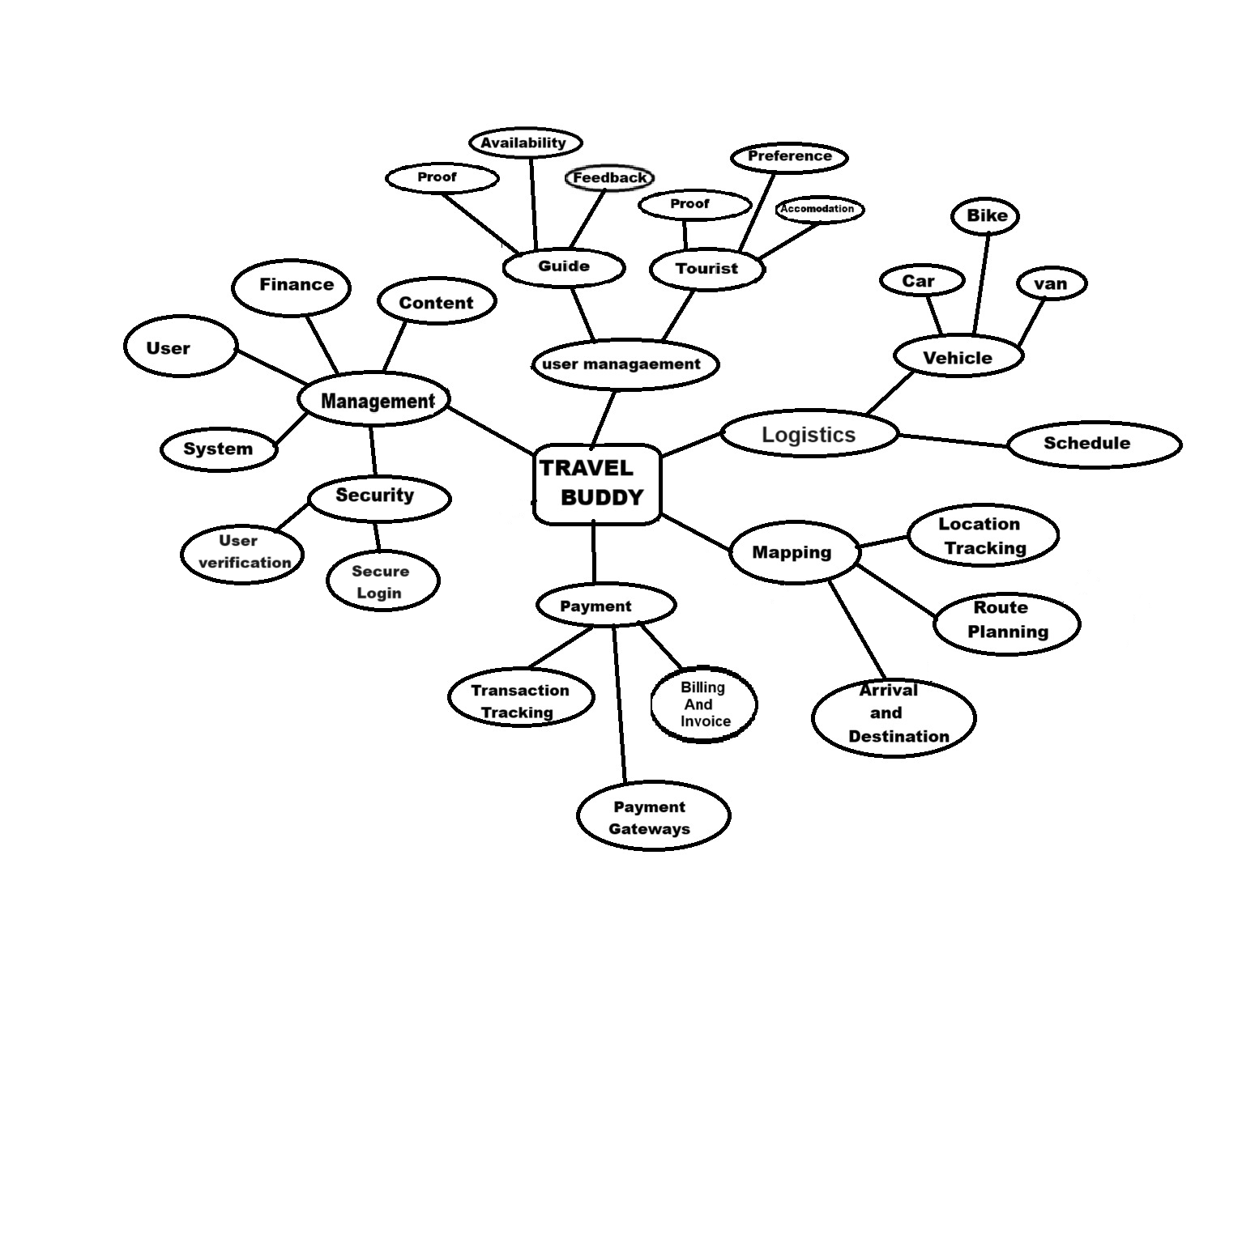

**Figure:2 - Mindmap**

**Travel Solutions Development**

The ideation phase is to find solutions to the major pain points identified earlier when traveling, like managing trip reservations, data security, and the elimination of barriers while communicating with guides locally. One of the most innovative concepts was the centralized trip planner that enables users to manage all reservations-including hotels, and activities-through a single interface.

We conducted Brainstorming session to identify the following ideas:

**6.1.1. Ideas on Generating Guides**

For the guides, some ideas developed in the ideation phase involved addressing the issues of marketing services, management of bookings and communication with international clients. Some key ideas that appear to emerge for the guides, among others, are:

**6.1.2. Dynamic Profile Builder:**

A feature call was proposed Dynamic Profile Builder. This feature would enable guides to build profile pages that are visually richer with multimedia - videos and images and reviews and more to attract more travellers to them. So, a guiding principle was to make guides distinct from all others by emphasizing their local knowledge and making it even more personalized to their profile based on services offered.

**6.1.3. Traveler-Guided Review System:**

It is a kind of review system that was proposed to establish trust between travellers and guides. For each of his travels, each traveller would be required to leave reviews. Guides would then have the opportunity to address these reviews and, thus help build their reputation together with improving services according to experiences from such reviews among the travellers.

**Table 2. Value proposition statement for Travel Buddy**

|  |  |
| --- | --- |
| **Component** | **Details** |
| For | Tourists traveling to new places (both domestic and international) |
| Who | Struggle to find trustworthy and knowledgeable local guides, as well as transportation services |
| Is a | Platform that connects tourists with verified local guides and offers travel vehicle accommodations |
| That | Ensures tourists have authentic, personalized experiences with easy access to local expertise and transportation |
| Unlike | Traditional tour services or random guide bookings, Travel Buddy offers transparent pricing, secure payments, and verified guide profiles |

**Table 3.** **Features and Functionalities of Travel Buddy**

| **Feature** | **Description** | **Target User** | **Current Functionality** | **Future Improvements** |
| --- | --- | --- | --- | --- |
| Traveller Registration | Allows travellers to create accounts, provide personal information, and set up travel preferences. | Travellers | Simple form with name, email, phone, password. | I added the feature of login through social media, automatic verification, and a guide based on reviews. |
| Guide Registration | Enables local guides to register, list services, and provide verification documents. | Local Guides | Basic registration with verification documents. | Introduce guide certification, instant background checks, and reviews to build trust. |
| Search and Match | Travellers can search for guides based on location, availability, and past reviews. | Travellers and Guides | Search based on location and date. | Add filters like guide language, activity specialization, and price range. |
| Messaging System | Direct communication between travellers and guides to arrange tours and ask questions. | Travellers and Guides | Basic text-based chat with no media sharing. | Add media sharing features (e.g., images, videos) and real-time translation functionality and group chat |
| Review and Rating | Travellers can review guides after a trip, rating them on various aspects such as safety and knowledge. | Travellers and Guides | 5-star rating system, written reviews allowed. | Amplify trusted guides by using weighted ratings, video reviews, and AI-based sentiment analysis. |
| Trip Planning Assistant | Suggests personalized travel itineraries based on preferences and location. | Travellers | Manual itinerary creation by users. | There will also be AI-based itinerary recommendations and automated bookings of accommodation, transport, and guides. |
| Secure Payment Gateway | Travellers can pay for guide services securely through the platform. | Travellers and Guides | Payment processing via third-party service. | Alternatively, local currencies, splitting payments for groups, and travel services integrations, such as with Uber, can be added. |
| Multilingual Support | Supports various languages for international travellers and guides. | Travellers and Guides | Limited language options (English, Hindi). | Provide language support for major global languages and add real-time language translation. |

**7.PROTOTYPE STAGE**

In the Stanford Design Thinking model, the Prototype stage refers to reifying ideas into testable, usable solutions that can be iterated upon. Thus, for Travel Buddy, the prototype stage is focused on low-fidelity versions of key feature implementations that will allow the team to actually envision, test, and refine the actual platform before full-scale development.

**7.1.Prototyping for Travellers**

Using what was learned from the empathize and define stages, several features were identified as key for the needs of the traveller. In the prototyping stage, the focus of Travel Buddy is to develop interactive models of the key features:

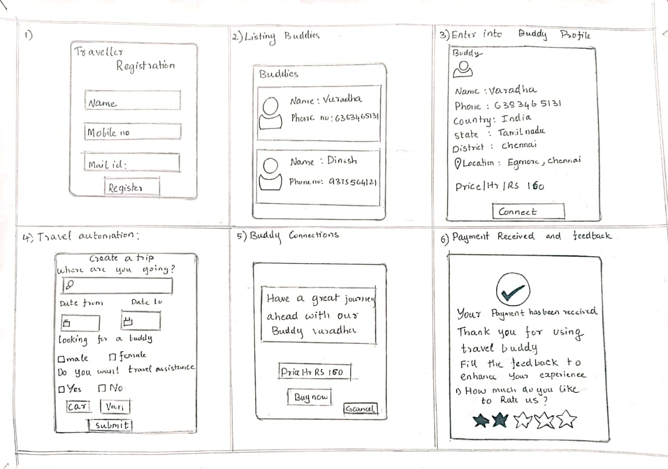

**Figure:3 – Prototype for Travellers**

**7.2.Centralized Booking Dashboard:**

Another major pain point for travellers is the management of multiple bookings across several platforms. To eliminate this headache, Travel Buddy prototyped a central booking dashboard, where all data on bookings are congregated in a single place. In the interface, a traveller can see hotel reservations, and activity arrangements. Thus, the prototype concentrates on its use with intuitive navigation and easy features, each sufficiently clear in its structure, and with ease with which one can change or cancel bookings.

**7.3.Secure Login and Data Protection:**

As the fear of data exposure is in everyone's minds, Travel Buddy really prototypes a secure login mechanism with MFA. This prototype focuses on the usability of users so as to be able to easily register and log into such a system by providing a secure platform for individual information. It has visuals like a password strength meter and, of course, an allowance for biometric authentication that makes the system both usable and safe at the same time.

**7.4.Prototyping Solution for Buddy**

At this prototype stage, for guides, their business and operational problems are solved. Developed into some of the must features identified at this stage, they work on prototypes:

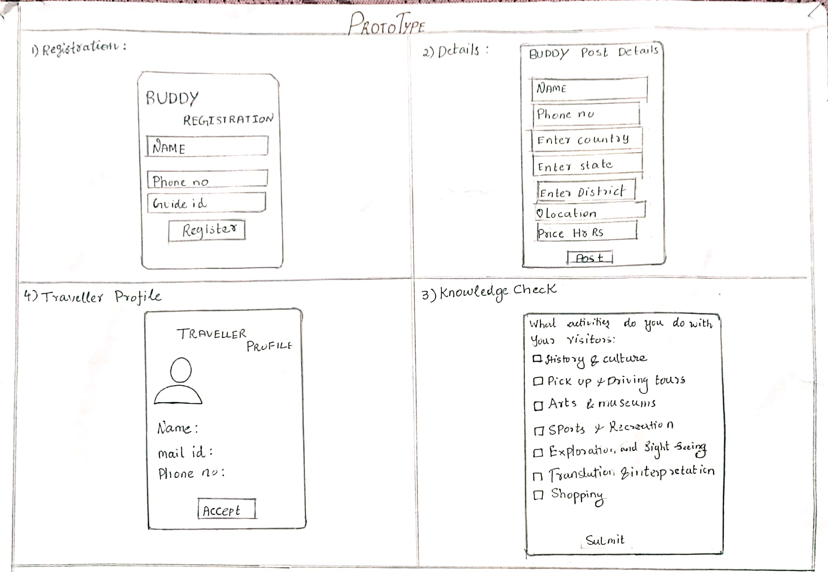

**Figure:4 – Prototype for Guides**

**7.5.Guide Marketing and Profile System:**

To make it easier for guides to look for clients, Travel Buddy creates a model profile system where guides can brag about their experience, abilities, and services. The prototype designed allows guides to upload pictures, list tours offered, and include client ratings in past experiences. The design would cover a clean and user-friendly interface by which guides can show their unique offerings in a professional manner for improved visibility of guiding potential clients.

**7.6.Guide Booking Management Tool:**

The guide has a booking management tool prototype, which can provide an easy management of bookings. Through it, he or she is able to view the details of the clients and update availability in real time. It may ensure that guides will be organized to respond quickly to inquiries from the traveller. This prototype focuses on simplifying the process or procedure involving the acceptance or refusal of bookings and managing its schedule.

**7.7.Low-Fidelity and High-Fidelity Prototypes**

At the prototype level, Travel Buddy creates low fidelity wireframes to describe functionality and flow of all features. Low fidelity wireframes are simple designs, focusing on layout and structure rather than making it aesthetically pleasing. The benefit of this level while testing the usability and navigation of the overall system with potential users is that low fidelity wireframes would be quite useful at this stage. For instance, a central dashboard for the traveller would first be created as a wireframe describing how different sections such as hotels, or activities would be arranged on the dashboard.

Once Travel Buddy gains feedback on low-fidelity prototypes, it moves onto high-fidelity prototypes. These are more refined and interactive, including polished design elements like colour schemes and typography as well as icons. This raises the fidelity of the prototypes so much that users can operate features as if in the final product, thus giving a better output when tested against user needs.

**Table 4. Working of Travel Buddy**

| **Stage** | **Traveller** | **Buddy** |
| --- | --- | --- |
| 1. Registration | - Traveler fills out a registration form - Provides traveller_name, traveller_email, traveller_password, traveller_phone - Verifies email through a confirmation link | - Buddy fills out a registration form - Provides buddy_name, buddy_email, buddy_password, buddy_phone - Verifies email through a confirmation link |
| 2. Profile Setup | Traveler completes her/his profile setup, e.g. profile picture, bio Sets travel preferences and interests | - Buddy creates the profile (profile photo, bio, etc.) - Sets availability and preferences |
| 3. Login | The travellers then input e-mail and password If the details are correct, logs into the system. - If forgotten password, uses recovery options | - Buddy enters email and password  - If all details are correct, log into the system. - If forgotten password, uses recovery options |
| 4. Welcome Tour | -The tourist is taken through a welcome tour or tutorial. -Introduced to core features and navigation | -The buddy is oriented on a welcome tour or tutorial. -Introduced to key features and navigation |
| 5. Dashboard | - Traveler views personalized dashboard - View/edit profile options, view travel plans, check connections - Access to search for Buddies Buddy views personalized dashboard | - Buddy views personalized dashboard  -Link to view/edit profile; manage travel requests; update availability. -Availability to search by Travellers |
| 6. Search & Discovery | -Buddies searched by the traveller based on search criteria (location etc.) and interests. - Surfs through Buddy profiles and sends connection requests | - Buddy looks for Travellers using given criteria, for instance, travel plans or interests. -Analyses Traveler profiles and accepts or declines requests |
| 7. Request/Match | - Traveller sends connection requests to chosen Buddies - Gets notification of connections requests from Buddies - Tracks request status | -Buddy accepts connectivity invitation updates from the Travellers -It reviews and accepts or declines requests. -It tracks request status |
| 8. Manage Connections | - Traveler manages existing connections - Communicates through messaging - Sets up travel plans and itineraries - Can block or remove connections | - Buddy manages existing connections - Communicates through messaging - Updates availability, manages the time schedule - Can block or remove connections |
| 9. Trip Details | - Traveler adds trip details (e.g., itinerary, destinations) - Edits or updates trip details as necessary - Shares trip information with connected Buddies | -Buddy views trip details shared by Travellers - Updates or suggests changes to trip plans - Coordination of information with Travellers |
| 10. Notifications | - Traveler receives notifications for connection requests, messages, and trip updates | Connection requests, messages, as well as trip updates give Buddy notifications. |
| 11. Communication | -Traveler uses messaging feature to convey messages. - Keeps track of conversation history | - Buddy uses the messaging feature for communication -It tracks the history of conversation. |
| 12. Feedback | - Traveller Feedback on Buddy Experience - Rates the Buddy - Can also provide reviews and suggestions - Can also provide reviews and suggestions | - Buddy provides feedback on Traveler experience - Rates the Traveler - Can also provide reviews and suggestions - Can also provide reviews and suggestions |
| 13. Support | - Traveler accesses support for issues or queries - Utilizes FAQs, contact support, or help centre | - Buddy accesses support for issues or queries - Utilizes FAQs, contact support, or help centre |
| 14. Settings & Preferences | - Traveler updates account settings, privacy preferences, and notification settings. | -This up-grades the account settings, availability preferences, and notification settings- Buddy |
| 15. Logout | -Traveler logs out of the system -Session ends and redirect the user to the login page | -The friend logs out of the system -Session ends and the user will be redirected to the login page |

**8.TEST AND FEEDBACK**

In the **Test and Feedback** stage, real users—both Travellers and guides—will use Travel Buddy’s core features to validate the platform's effectiveness in meeting their needs. This phase is crucial to ensuring the platform’s usability, functionality, and overall user experience.

**8.1.Team Members' Feedback:**

**8.1.1. User Experience and Usability:**

* **Guide Registration Process:** Team members found the guide registration straightforward, but some suggested adding clearer guidance on the ID card upload section for smoother onboarding.
* **Traveler Dashboard:** The traveler dashboard was well-received, with team members noting it’s easy to navigate. However, a few felt that displaying booking history could further enhance the user experience by helping Travellers track previous trips.

**8.1.2. Feature Functionality:**

* **Booking System:** Overall, the booking system was seen as functional and intuitive. Some feedback suggested implementing a confirmation prompt before finalizing a booking to avoid accidental submissions.
* **Real-Time Chat:** The chat feature worked effectively, though a few recommended adding typing indicators or “seen” statuses to make communication more responsive and user-friendly.

**8.1.3. Performance and Reliability:**

* **Loading Times:** The platform loads quickly for most users, though a few noticed slight delays when accessing the guide profiles page. Optimizing the image loading process may improve this.
* **System Stability:** Team members tested different features simultaneously and reported no significant crashes, indicating a strong stability foundation.

**8.1.4. Visual Design and Accessibility:**

* **Design Consistency:** The layout and color scheme were widely appreciated, but there were a few suggestions to increase font sizes slightly on mobile devices for better readability.
* **Accessibility Enhancements:** Some team members recommended adding more alt-text for images and ensuring compatibility with screen readers for a more inclusive experience.

**8.1.5. Security and Data Privacy:**

* **User Data Protection:** Team members expressed confidence in the platform’s approach to data security. They suggested adding a brief description or tooltip during the registration process to reassure users of data privacy practices.
* **Secure Payment Flow:** Initial tests of the payment flow were successful, but team members recommended additional security prompts to provide users with added confidence during payment transactions.

**8.1.6.Feedback from Other Team members:**

1. **Communication Features:** Feedback highlighted the value of real-time chat between travellers and guides, though some recommended offering quick response templates for guides to save time in frequently asked scenarios.
2. **Additional Features:** There were suggestions to include options like “favourite a guide” or “rebook with a guide” to foster repeat engagement. They believe these features could enhance user retention.
3. **Support and Help Section:** Some contributors felt that a clearly labelled “Help” or “FAQ” section would be beneficial. They noted that users may have questions about certain features and would appreciate an accessible support guide.
4. **Performance on Mobile Devices:** Contributors testing on mobile devices found the platform easy to use, though some recommended further mobile optimization, especially for guide profile pages and map views.

**8.2.Testing with Travellers**

Testing with Travellers is focused on evaluating how well Travel Buddy’s features address the specific needs of Travellers, as well as identifying areas for improvement. Key activities include:

* **User Testing Sessions**:
  + Travellers participate in testing sessions, using prototypes of key features like the booking dashboard, secure login, and real-time chat. They are given specific tasks, such as booking a trip, accessing travel documents, and messaging guides.
  + Observing their interactions provides insights into the ease of use and intuitiveness of each feature, highlighting any challenges they may face.
* **Scenario-Based Testing**:
  + Travellers are presented with realistic scenarios, like planning a trip itinerary or changing booking details. This helps determine how effectively Travel Buddy meets their needs in common travel situations and identifies any areas where improvements are needed.

**8.3.Testing with Guides**

Testing with guides ensures that the platform’s features designed to support their needs—such as profile management, booking control, and traveler communication—are user-friendly and reliable.

* **Scenario-Based Testing**:
  + Guides are given practical scenarios, such as updating profiles, accepting bookings, and communicating with Travellers. This simulation of real-life tasks helps the development team understand whether the platform meets guides’ expectations and provides a smooth user experience.
  + Any usability issues or feature gaps are documented for further refinement.

**9. RE-DESIGN AND IMPLEMENTATION AND RESULT**

In this phase, **Travel Buddy** undergoes a final review, incorporating user feedback to enhance usability and functionality, aiming to deliver a seamless platform experience for both Travellers and guides.

**9.1.1 User Experience and Usability Enhancements**

* **Clearer Guide Registration Process:** To improve onboarding for guides, especially regarding the ID card upload, an updated step-by-step guide and tooltips will be added. This will clarify requirements and ensure smoother registration.
* **Enhanced Traveler Dashboard:** Adding a booking history feature to the traveler dashboard will allow users to view previous trips and make informed rebooking decisions, supporting an improved user experience.

**9.1.2. Feature Functionality Improvements**

* **Booking System Refinement:** A confirmation prompt will be introduced before finalizing bookings, reducing accidental bookings. This added layer of validation will improve the booking process’s reliability and user confidence.
* **Enhanced Real-Time Chat:** To make communication smoother and more responsive, “typing” indicators and “seen” statuses will be integrated into the chat. Additionally, guides will have quick response templates for frequently asked questions, helping streamline guide-traveler interactions.

**9.1.3. Performance Optimization**

* **Optimized Loading Times for Profiles:** To address delays when accessing guide profiles, image-loading processes will be optimized, implementing lazy loading and compression techniques to improve speed, particularly on mobile devices.
* **Increased Stability Across Features:** The team will continue rigorous stress testing, especially under concurrent use of multiple features, ensuring high system stability during peak usage.

**9.1.4. Visual Design and Accessibility Adjustments**

* **Responsive Font and Layout:** Font sizes and layout adjustments for mobile devices will improve readability and interface usability on smaller screens, ensuring the platform is mobile-friendly and accessible.
* **Screen Reader Compatibility and Alt-Text for Images:** To enhance accessibility, alt-text for images and improved compatibility with screen readers will be added, ensuring inclusivity for users with disabilities.

**9.1.5. Security and Data Privacy Enhancements**

* **Improved Data Privacy Transparency:** A tooltip or brief description during registration will inform users about data protection measures, building user trust in data security.
* **Enhanced Payment Security Features:** Additional security prompts and messages will be added to the payment flow, reassuring users of the safety of transactions on Travel Buddy.

**10.CONCLUSION**

Travel Buddy is a platform created to enhance travel experiences by connecting Travellers with knowledgeable local guides for personalized assistance and insights. Designed with user-friendly features, it enables Travellers to find guides based on location, view profiles, and securely book services, while guides can manage bookings and profiles efficiently. Core functionalities, such as real-time chat, feedback, and travel assistance options, make Travel Buddy a valuable tool for Travellers seeking authentic experiences. By continuously gathering user feedback, we refine and adapt the platform to meet the evolving needs of both Travellers and guides, fostering meaningful connections and unforgettable journeys.

**11.FUTURE WORK**

For our project Travel Buddy, future work includes a whole spectrum of enhancements and features that will improve user experience and platform capabilities. Among these are some of the followings:

**1. AI Chat Customer Support:** Implement AI chat support to manage basic queries in terms of bookings and payments, improving customer support.

**2. Certification of Guides and Training:** Introduce certification of guides followed by optional training resources to improve quality and further enhance the skills.

**12. LEARNING OUTCOMES**

Travel Buddy Learning Outcomes Learning Outcomes is the reflection on key insights and lessons learned throughout the development of Travel Buddy. This is very important in the development process as it will be used to understand what impact a project can have on its stakeholders and identify areas needing improvement while applying those to future projects. It captures all the experience accumulated along the several phases of the project, from research up to the implementation phase, and finally the user feedback.

**Understanding the Needs and Problems of the User**

Developing Travel Buddy with deep learning outcomes, not only for understanding what the user requires but also for every challenge that a traveller or a guide might face in making this application.

Some key pain points were brought to light, particularly regarding hassle in dealing with multiple bookings, concerns over data security, and a bit of issues regarding communication with the local guides. Given the user-centric nature of the needs of the project and including features such as Centralized Booking Dashboard and among others, meeting those needs meant taking a user-centred approach to design.

**Why User Feedback?**

It was clearly learned through this process of design thinking that user feedback is at the heart of any end product development. The main takeaways are:

**Worth of Testing:**

Real user testing provided some crucial input about whether well the features meet the need. The feedback of the traveller and guide accounted for some vital refinements; hence it ensured the platform will be intuitive, functional, and even aligned to the expectations of the user.

**Ongoing Improvement:**

The project demonstrated that continuous improvement is necessary for success. The constant update and iteration based on user feedback were good ways to address issues, improve on features, and adapt to ever-changing user needs.

**Empathy and User-Centric Design:**

In the Empathize stage, it became very important to understand what users required from them. This user-centricity was foundational in informing which features were considered for designing and developing them directly from the pain points and needs of users.

**Learning Outcomes from Design Thinking**

The aim of the course is that, upon its end, students have mastered the Design Thinking process itself and its five key phases: empathize, define, ideate, prototype, and test. Immersion activities can be learned to create empathy maps that would help in deep understanding of user needs. Students will learn skills for defining key problems based on user personas and apply ideation techniques to create creative solutions.

Further, they are going to develop prototypes centered on value propositions, which they can test and come back with the feedback in order to ensure that it all works properly to answer the needs of the user. It is an extremely practical course that teaches how to translate theories into something innovative and user-centered.

**REFERENCES**

**Journal Papers**

[1] Tour Vista: Tour Guide Web Application H. M.C.H. Karunathilaka

1, J.A.M.P. Jayasinghe2, W.M.A.S. Gunasekara3, W.T.R.P Fernando4, D.I. De Silva5, M.P. Gunathilaka6

[2] Comparative Study of Tourism Websites in India – With special reference to South India Dr. Kavita Chavali and Dr. Subrat Sahu

[3] A STUDY ON THE CONCEPTS OF DESIGN THINKING Mrs. P. Deepa

Assistant Professor, MBASRMIST Ramapuram, Chennai, Tamil Nadu, India

[4] Design Thinking: A Review PaperVikas T N1, Vinay C T2, Habeeba Amrutha Hegaddathy3, Rizwan N Shaikh4, Mrs. Vidya5

**Websites**

[5] Buhalis, 2019 – Digital transformation in tourism and hospitality:  
<https://journals.sagepub.com/doi/10.1177/14673584231198414>

[6] Fitzpatrick, D. (2019). The Future of Travel: How Technology is Changing the Way We Explore the World - <https://www.theguardian.com/haval-ultra-hybrid/2023/feb/03/the-road-to-the-future-how-tech-is-changing-our-everyday-lives>

[7] Paris, J. (2017). Solo Travel Companions: A Qualitative Study of Motivations, Experiences, and Challenges - <https://www.researchgate.net/publication/346452536_What_motivates_and_hinders_people_from_travelling_alone_A_study_of_solo_and_non-solo_travellers>

[8] Gössling, S., & Hall, C. M. (2016). Tourism and Sustainability: Development, Impacts, and Management - <https://www.routledge.com/tourism-hospitality-and-events/tourism/tourism-developmentimpacts>

[9] Couchsurfing: <https://www.couchsurfing.com/>

[10] Meetup: <https://www.meetup.com/>

[11] ToursByLocals: <https://www.toursbylocals.com/>